Chapter 3, Problem 21.

For the circuit in Fig. 3.70, find v₁ and v₂ using nodal analysis.

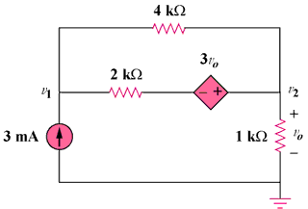

Figure 3.70
For Prob. 3.21.

